Name

Mathematics Extension 1 Year 11
Parametric Form

Book 1 |  | Version: 261020  Feedback:  https://MrDingMaths.com
Contents
Syllabus Content 2
Learning Intention 3

Syllabus Content
ME1-11-01 solves problems involving inequalities, functions and their inverses, graphical relationships between functions, and parametric equations
Parametric form of a function or relation
- Recognise that a curve may be represented by two parametric equations that give $x$ and $y$ as functions of a parameter and that the curve may also have a Cartesian equation in $x$ and $y$
- Express linear and quadratic functions and circles in parametric form
- Convert linear and quadratic functions and circles from parametric form to Cartesian form
- Graph linear and quadratic functions and circles expressed in parametric form

Parametric Form

- Parametric Form of an Equation
- Cartesian equations directly link $x$ and $y$ in one equation (like $y=2x+1$).
- In parametric equations, $x$ and $y$ are defined separately using a third variable (the parameter). Instead of $y$ depending on $x$, both $x$ and $y$ depend on the parameter.
- Parametric equations are useful as they track multiple changing values at once.
They have essential applications in future calculus topics such as projectile motion.

- Sketching a curve from its parametric equations
- $x=t+2$
$y=2t$
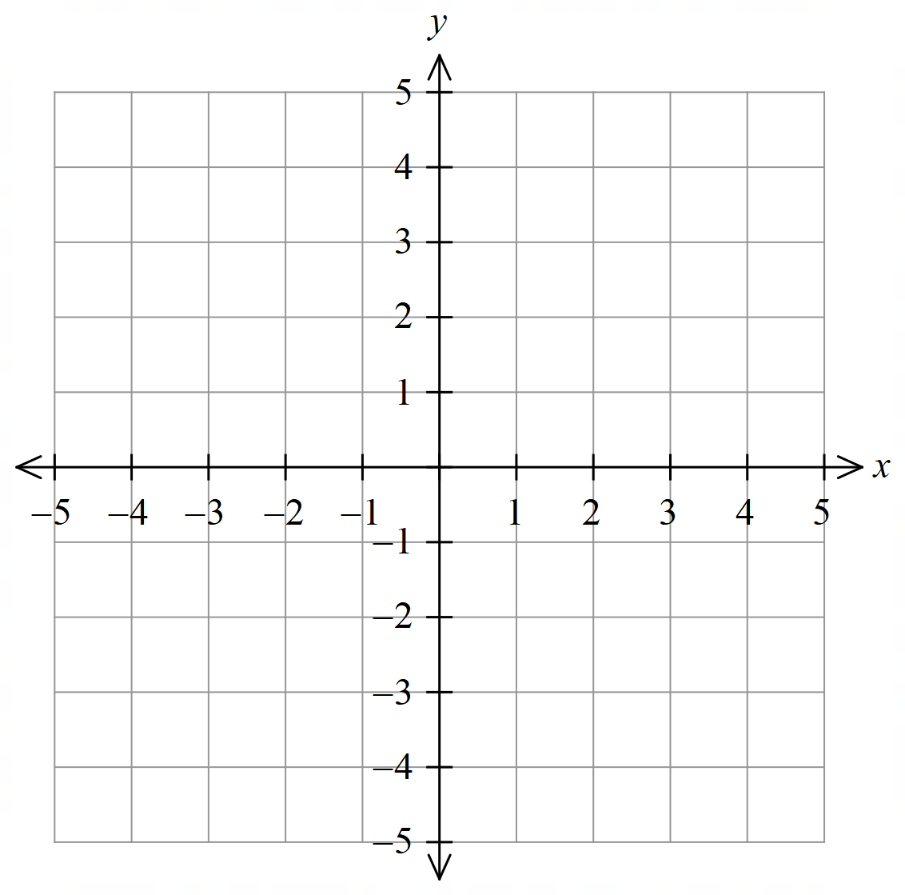
$$t$$ | $$-2$$ | $$-1$$ | $$0$$ | $$1$$ | $$2$$
$$x$$
$$y$$

Express these parametric equations
as a single Cartesian equation.

- $x=2t$
$y=2t^{2}$

$$t$$ | $$-2$$ | $$-1$$ | $$0$$ | $$1$$ | $$2$$
$$x$$
$$y$$

Express these parametric equations
as a single Cartesian equation.

- Converting from Parametric Form to Cartesian Form
- To convert parametric equations to Cartesian form, we need to eliminate the parameter:
- Rearrange one of the equations so that the parameter is the subject.
- Substitute the parameter into the other equation.

- Example Convert from parametric form to Cartesian form
Worked example | Your Turn
Find the Cartesian equation.  $x=3t+1$ (1)  $y=2t-3$ (2)  1. Rearrange  Using (1): $t=$ $\frac{x-1}{3}$  2. Substitute  Sub $t=$ $\frac{x-1}{3}$ into (2)  $$y=2\left(\frac{x-1}{3}\right)-3$$  $$3y=2\left(x-1\right)-9$$  $$3y=2x-2-9$$  $$3y=2x-11$$  $$2x-3y-11=0$$ | Find the Cartesian equation.  $x=2t-1$  $$y=3t+2$$  $$3x-2y+7=0$$
Find the Cartesian equation.  $x=2p$ (1)  $y=p^{2}-3$ (2)  1. Rearrange  Using (1): $p=$ $\frac{x}{2}$  2. Substitute  Sub $p=$ $\frac{x}{2}$ into (2)  $$y={\left(\frac{x}{2}\right)}^{2}-3$$  $$y=\frac{x^{2}}{4}-3$$  $$y=\frac{x^{2}}{4}-3$$ | Find the Cartesian equation.  $x=4p$  $y=p^{2}+1$  $$y=\frac{x^{2}}{16}+1$$

- Converting from Parametric Form to Cartesian Form
- To convert Cartesian equations to parametric form, we need to define a parameter.
How to define the parameter will be given by the question.
- Substitute the parametric equation of $x$ into the Cartesian equation.
- Rearrange to make $y$ the subject and simplify.

- Example Convert from Cartesian form to parametric form
Worked example | Your Turn
$5x-2y+10=0,$ using $x=4t$  $5\left(4t\right)-2y+10=0$  $$20t-2y+10=0$$  $$2y=20t+10$$  $$y=10t+5$$  $$∴x=4t,$$  $$y=10t+5$$ | $3x+y-3=0$, using $x=1-t$  $$x=1-t,$$  $$y=3t$$
$y=x^{2}+3x-1,$ using $x=2t-2$  $$y={\left(2t-2\right)}^{2}+3\left(2t-2\right)-1$$  $$y=4t^{2}-8t+4+6t-6-1$$  $$y=4t^{2}-2t-3$$  $$∴x=2t-2,$$  $$y=4t^{2}-2t-3$$ | $x^{2}=4\left(y-3\right)$, using $x=2t$  $$x=2t,$$  $$y=t^{2}+3$$

Foundation

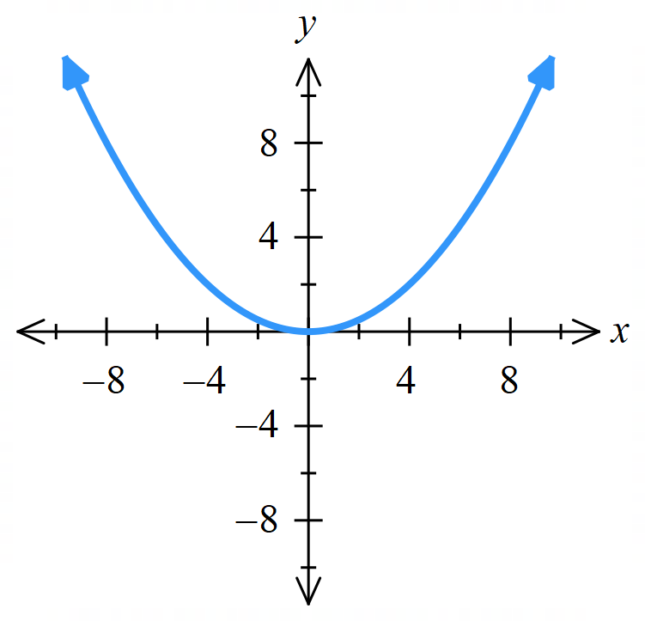
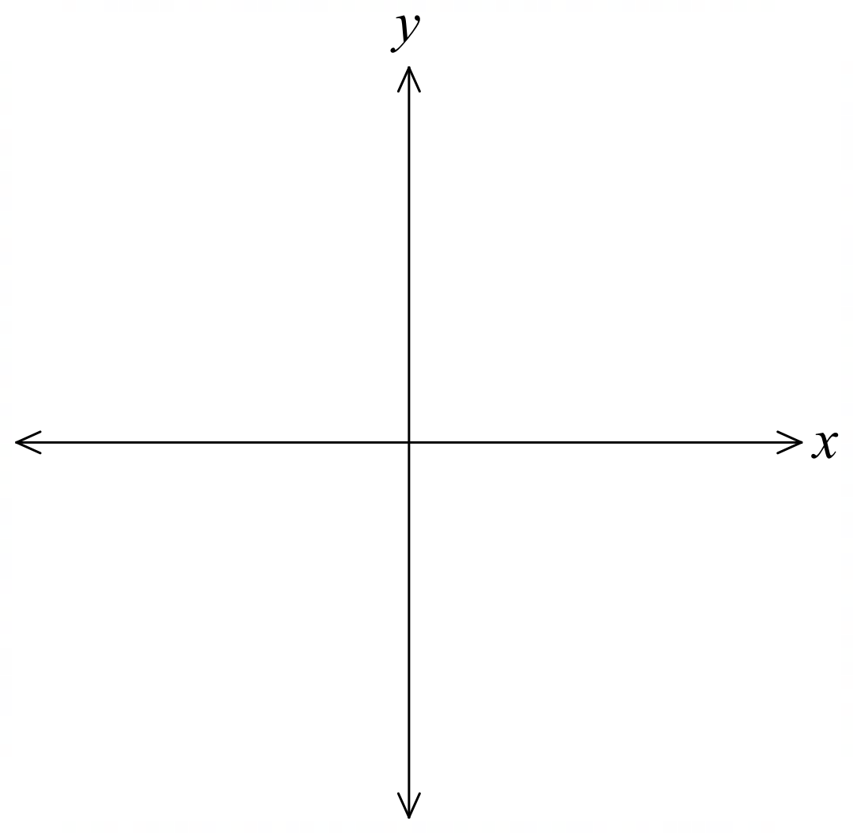
  - Complete the table for $x=4t$, $y=2t^{2}$.
$$t$$ | $$-2$$ | $$-1$$ | $$0$$ | $$1$$ | $$2$$
$$x=4t$$ | $$-8$$ | $$-4$$ | 0 | 4 | 8
$$y=2t^{2}$$ | 8 | 2 | 0 | 2 | 8

  - Sketch the graph.

  - Eliminate the parameter to find the Cartesian equation.

$$y=\frac{x^{2}}{8}$$
  - The curve is a parabola. What value of $t$ gives the coordinates of the vertex?
$$t=0$$

- Consider the curve defined parametrically by $x=3t$, $y=t^{2}$.
  - Complete the table.
$$t$$ | $$-3$$ | $$-2$$ | $$-1$$ | $$0$$ | $$1$$ | $$2$$ | $$3$$
$$x=3t$$ | – 9 | – 6 | – 3 | 0 | 3 | 6 | 9
$$y=t^{2}$$ | 9 | 4 | 1 | 0 | 1 | 4 | 9

  - Eliminate the parameter and find the Cartesian equation.

$$y=\frac{x^{2}}{9}$$
  - What value of $t$ would give the coordinate $\left(6,4\right)$?

$$t=2$$
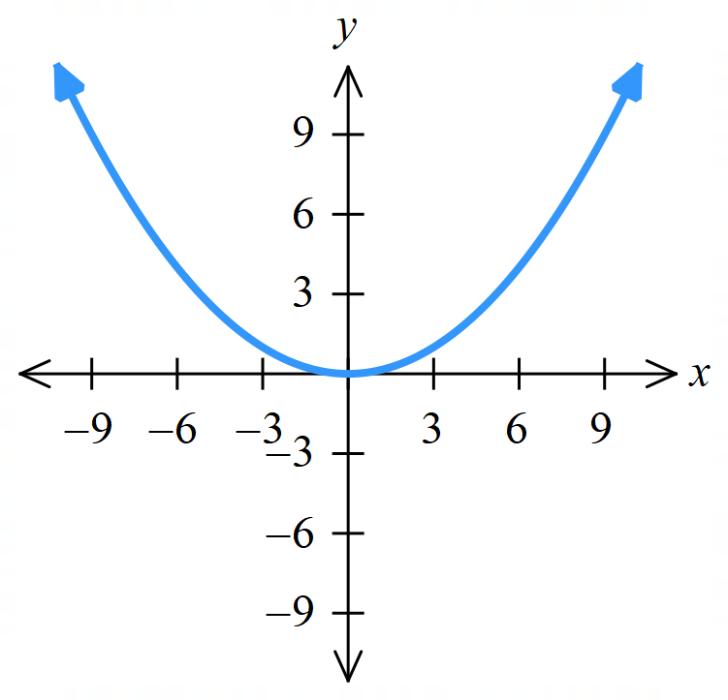
  - Sketch the curve.

  - Show that the point $\left(cp,\frac{c}{p} \right)$ lies on the hyperbola $xy=c^{2}$, where $c$ is a constant.
$$xy=(cp)·\left(\frac{c}{p}\right)$$
$$=cp·\frac{c}{p}$$
$$=c²$$
  - Complete the table of values for $x=2p, y=$ $\frac{2}{p}$.
$$p$$ | $$-3$$ | $$-2$$ | $$-1$$ | $$-\frac{1}{2}$$ | $$0$$ | $$\frac{1}{2}$$ | $$1$$ | $$2$$ | $$3$$
$$x=2p$$ | – 6 | – 4 | – 2 | – 1 | 0 | 1 | 2 | 4 | 6
$$y=\frac{2}{p}$$ | $$- \frac{2}{3}$$ | – 1 | – 2 | – 4 | Undef. | 4 | 2 | 1 | $$\frac{2}{3}$$
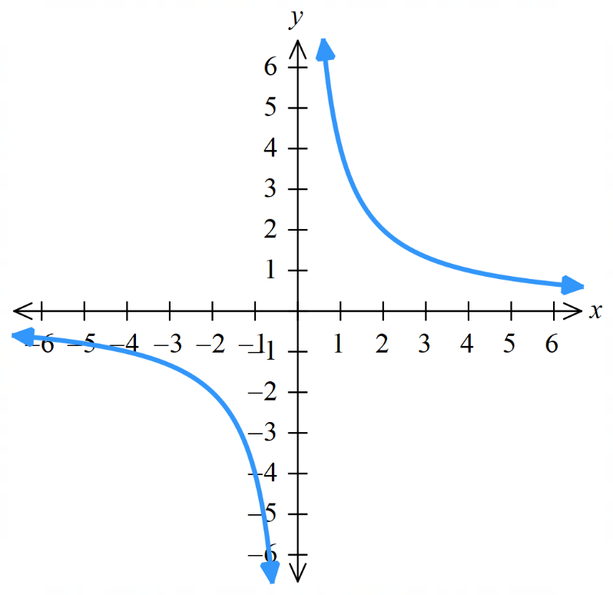
  - Sketch the graph.

- Consider the parametric equations $y=2t-1$ and $x=t-2$.
  - Complete the table.
$$t$$ | $$-2$$ | $$-1$$ | $$0$$ | $$1$$ | $$2$$
$$x=t-2$$ | – 4 | – 3 | – 2 | – 1 | 0
$$y=2t-1$$ | – 5 | – 3 | – 1 | – 1 | 3

  - Explain, using the table, why the graph is a straight line.

As $x$ changes, $y$ changes by a constant amount.
In this case, as $x$ increases by 1, $y$ increases by 2.
Therefore, this is a straight line.
  - From the table, find the $y$-intercept and gradient.

Using any two points, gradient is 2.
Using last column, when $x=0, y=3$ so $y$– intercept is 3.
  - Eliminate $t$ to find the Cartesian equation and check it with part c.
$$t=x+2$$
$$y=2\left(x-2\right)-1$$
$$y=2x+3$$

Development
- Eliminate the parameter and find the Cartesian equation of the curve.
Hint: use $a^{2}+b^{2}={\left(a+b\right)}^{2}-2ab$
$$x=p+\frac{1}{p} \\ y=p^{2}+\frac{1}{p^{2}}$$
Using identity $a^{2}+b^{2}={\left(a+b\right)}^{2}-2ab:$
$$y={\left(p +\frac{1}{p}\right)}^{2}-2$$
$$∴y=x^{2}-2$$

- Write in Cartesian form.
- $x=2t,$$$y=3t-4$$  $$3x-2y-8=0$$ | - $x=3n-2,$$$y=2n-5$$  $$2x-3y-11=0$$ | - $x=-6t,$$$y=3t+2$$  $$x+2y-4=0$$
- $x=r-3$  $$y=r^{2}+1$$  $$y=x^{2}-3x+6$$ | - $x=2p+3,$$$y=p^{2}$$  $$x^{2}-6x-4y+9=0$$ | - $x=4k-7,$$$y=2k^{2}+k$$  $$x^{2}+16x-8y+63=0$$

- Write each function in parametric form, using the given equation for $x$.
- $3x-4y+24=0,$$$x=4t$$  $$x=4t,y=3t+6$$ | - $y=x^{2},$$$x=2t-1$$  $$x=2t-1,y=4t^{2}-4t+1$$ | - $y=2x^{2}-3x+4,$$$x=1-t$$  $$x=1-t,y=2t^{2}-t+3$$

Mastery
- 2023 HSC Extension 1 Band 3
The parametric equations of a line are given by $x=1+3t, y=4t$.
Find the gradient and $y$-intercept of this line.

$$t=\frac{x-1}{3}$$
$$y=4\left(\frac{x-1}{3}\right)$$
$$y=\frac{4}{3}x-\frac{4}{3}$$
Gradient $\frac{4}{3},$y-int $\frac{4}{3}$
- 2022 HSC Extension 1 Band 4
A curve is defined by $x=2+t$ and $y=3-2t^{2}$ for $-1≤t≤0$.
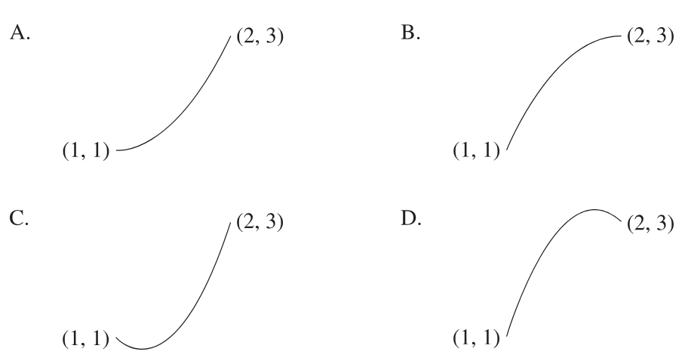
Which of these best represents the curve?

Cartesian equation is $y=3-2{\left(x-2\right)}^{2}$
Concave down parabola with maximum at $\left(2,3\right)$
$$∴B$$

- HSC Extension 1 Sample Question Band 4
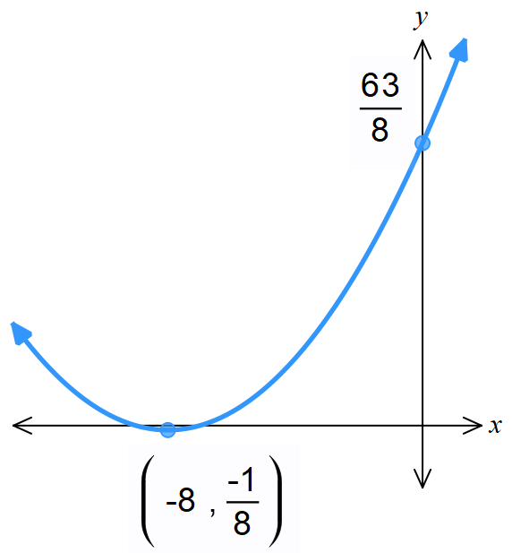
  - Sketch the graph of the function defined by $x=4t-7, y=2t^{2}+t$.

$$t=\frac{x+7}{4}$$
$$y=2{\left(\frac{x+7}{4}\right)}^{2}+\left(\frac{x+7}{4}\right)$$
This simplifies to
$$8y=x^{2}+16x+63$$
$$y=\frac{1}{8}\left(x+7\right)\left(x+9\right)$$
Turning point at $x=-8, y=-$ $\frac{1}{8}$

  - State the domain and range of the function.

$$x∈R , y≥-\frac{1}{8}$$

Parametric Equation of a Circle

- Parametric Equation of a Circle
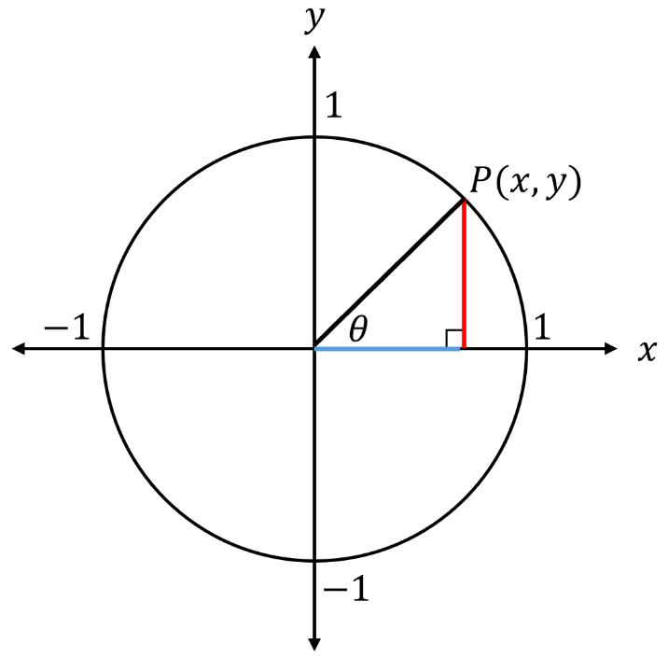
From your knowledge of trigonometry,
remember that we can define a unit circle with:

$x=\cos{θ}$
$y=\sin{θ}$

we can use Pythagoras’ Theorem to write:

$x^{2} + y^{2} =1$

………… $+$ ………… $=1$
It shows that we can define a circle using the parameter $θ$.
Note that this is the Pythagorean identity.

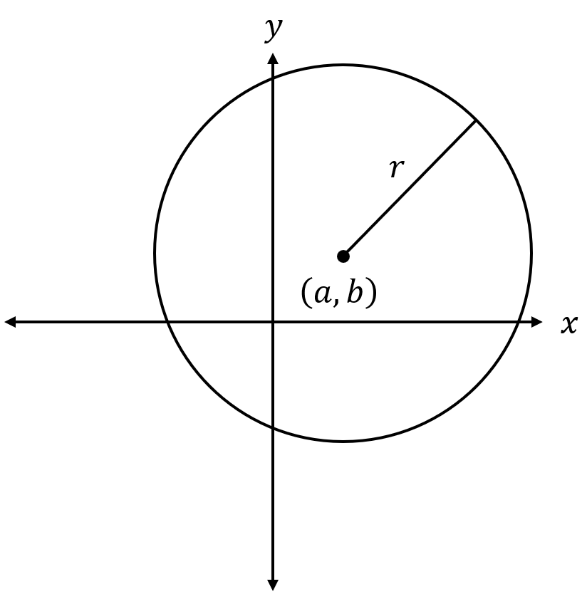
Consider a circle with centre $\left(a,b\right)$ and radius $r.$

${\left(x-a\right)}^{2}+{\left(y-b\right)}^{2}=r^{2}$

Divide by $r^{2}$

………… $+$ ………… $=1$

By relating this to $\cos^{2}{θ}+\sin^{2}{θ}=1$.

We should define:

$\cos{θ}=$ ………………… and $\sin{θ}=$ …………………

$∴x=$ ………………… and $y=$ ……………………

- Parametric Form of a Circle
Circle centred at the origin | Circle centred at $\left(a,b\right)$
Cartesian equation:  $$x^{2}+y^{2}=r^{2}$$  Parametric equations:  $$x=r\cos{θ}$$  $$y=r\sin{θ}$$ | Cartesian equation:  $${\left(x-a\right)}^{2}+{\left(y-b\right)}^{2}=r^{2}$$  Parametric equations:  $$x=r\cos{θ}+a$$  $$y=r\sin{θ}+b$$
- To convert the parametric form of a circle to Cartesian form:
- Rearrange given equations to make $\cos{θ}$ and $\sin{θ}$ the subject.
- Substitute into $\cos^{2}{θ}+\sin^{2}{θ}=1$.

- Example Convert parametric form of a circle to Cartesian form
Worked Example | Your Turn
Find the Cartesian equation of a curve whose parametric equations are:  $$x=2\cos{θ} y=2\sin{θ}$$  1. Rearrange  $$\cos{θ}=\frac{x}{2} \sin{θ}=\frac{y}{2}$$  2. Substitute into $\cos^{2}{θ}+\sin^{2}{θ}=1$  $${\left(\frac{x}{2}\right)}^{2}+{\left(\frac{y}{2}\right)}^{2}=1$$  $$\frac{x^{2}}{4}+\frac{y^{2}}{4}=1$$  $$x^{2}+y^{2}=4$$ | Find the Cartesian equation of a curve whose parametric equations are:  $x=5\cos{θ} y=5\sin{θ}$  $$x^{2}+y^{2}=25$$
Find the Cartesian equation of a curve whose parametric equations are:  $$x=4+3\cos{θ} y=3+3\sin{θ}$$  1. Rearrange  $$\cos{θ}=\frac{x-4}{3} \sin{θ}=\frac{y-3}{3}$$  2. Substitute $\cos^{2}{θ}+\sin^{2}{θ}=1$  $${\left(\frac{x-4}{3}\right)}^{2}+{\left(\frac{y-3}{3}\right)}^{2}=1$$  $$\frac{{(x-4)}^{2}}{9}+\frac{{(y-3)}^{2}}{9}=1$$  $${\left(x-4\right)}^{2}+{\left(y-3\right)}^{2}=9$$ | Find the Cartesian equation of a curve whose parametric equations are:  $x=3+2\cos{θ} y=2\sin{θ}-4$  $${\left(x-3\right)}^{2}+{\left(y+4\right)}^{2}=4$$

- Parametric Form of a Circle
- To convert the Cartesian form of a circle to parametric form:
- Rewrite in the form ${\left(\frac{x-a}{r}\right)}^{2}$ $+$ ${\left(\frac{y-b}{r}\right)}^{2}$ $=1$
- Define $\cos{θ}=$ $\frac{x-a}{r}$ and $\sin{θ}=$ $\frac{y-b}{r}$
- Rearrange to make $x$ and $y$ the subjects.

You could also memorise $x=r\cos{θ}+a$, $y=r\sin{θ}+b$.

- Example Convert Cartesian form of a circle to parametric form
Worked Example | Your Turn
Write in parametric form.  $${\left(x-1\right)}^{2}+{\left(y+2\right)}^{2}=9$$  1. Rewrite = 1  $$\frac{{\left(x-1\right)}^{2}}{9}+\frac{{\left(y+2\right)}^{2}}{9}=1$$  $${\left(\frac{x-1}{3}\right)}^{2}+{\left(\frac{y+2}{3}\right)}^{2}=1$$  2. Define  $$\cos{θ}=\frac{x-1}{3}$$  $$\sin{θ}=\frac{y+2}{3}$$  3. Rearrange  $$x=3\cos{θ}+1$$  $$y=3\sin{θ}-2$$ | Write in parametric form.  ${\left(x+3\right)}^{2}+{\left(y-2\right)}^{2}=16$  $$x=4\cos{θ}-3$$  $$y=4\sin{θ}+2$$

Foundation
- Write in Cartesian form.
- x = 6 cos θ,  y = 6 sin θ  $$x^{2}+y^{2}=36$$ | - x = sin θ,  y = cos θ + 1  $$x^{2}+{\left(y-1\right)}^{2}=1$$ | - x = 5 + 4 cos θ,  y = 2 + 4 sin θ  $${\left(x-5\right)}^{2}+{\left(y-2\right)}^{2}=16$$

- Write each equation of a circle in parametric form with the parameter $θ$.
- $x^{2}+y^{2}=4$  $$x=2cosθ$$  $$y=2sinθ$$ | - ${\left(x-3\right)}^{2}+{\left(y+1\right)}^{2}=36$  $$x=3+6cosθ$$  $$y=-1+6sinθ$$ | - $x^{2}+4x+y^{2}-5=0$  $$x=-2+3cosθ$$  $$y=3sinθ$$

  - Show that $x=a+r\cos{θ}$ and $y=b+r\sin{θ}$ define a circle with centre $\left(a,b\right)$ and radius $r$.
Rearranging:
$$cos θ =\frac{x - a}{r}$$
$$sin θ =\frac{y - b}{r}$$
Using Pythagorean identity cos²θ + sin²θ = 1:
$${\left(\frac{x - a}{r}\right)}^{2} + {\left(\frac{y - b}{r}\right)}^{2} = 1$$
Multiplying by r²:
$$(x - a)² + (y - b)² = r²$$
This is the equation of a circle with centre (a,b) and radius r.

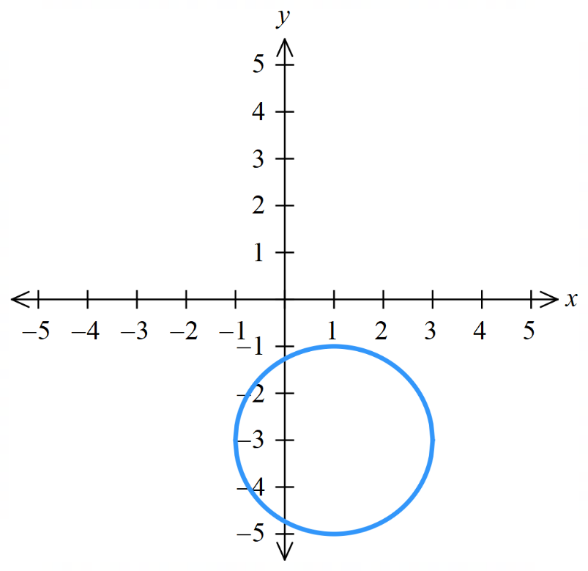
  - Hence sketch the curve $x=1+2\cos{θ}, y=-3+2\sin{θ}.$
Show the intercepts.

${\left(x-1\right)}^{2}+{\left(y+3\right)}^{2}=4$, $y$-intercepts at $y=-3±\sqrt{3}$

Development
- HSC Sample Question Band 3
Determine the Cartesian equation of the circle given by the parametric equations
$$x=-3+4\cos{θ} y=1-4\sin{θ}$$
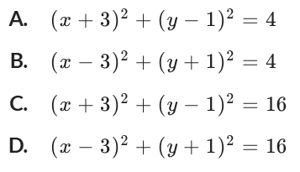

C

- HSC Sample Question Band 3
A circle has equation $x^{2}-10x+y^{2}+6y+25=0$.
Express the circle in parametric form.

By completing the square, ${\left(x-5\right)}^{2}+{\left(y+3\right)}^{2}=9$
$$x=5+3\cos{θ}$$
$$y=-3+3\sin{θ}$$

- 2019 VCE Specialist Maths
The curve given by $x=3\sec{t}+1$ and $y=2\tan{t}-1$ can be expressed in Cartesian form as:
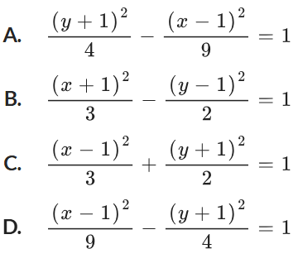

$$\sec{t}=\frac{x-1}{3}$$
$$\tan{t}=\frac{y+1}{2}$$
$${\left(\frac{x-1}{3}\right)}^{2}-{\left(\frac{y+1}{2}\right)}^{2}=1$$
$$\frac{{\left(x-1\right)}^{2}}{9}-\frac{{\left(y+1\right)}^{2}}{4}=1$$
D

Mastery
- Different parametric representations may result in the same Cartesian equation.
The graphical representation may be different, due to domain and range restrictions.
  - Find the Cartesian equation of $x=2-t$and $y=t-1$ and sketch the graph.
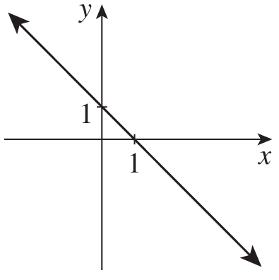

t = 2 - x
Substituting into y = t - 1:
y = (2 - x) - 1
y = 1 - x
∴ x + y = 1

  - Find the Cartesian equation of the curve $\left(\sin^{2}{t},\cos^{2}{t}\right)$.
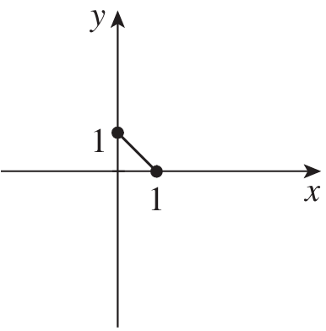
Explain why $0≤x≤1$ and $0≤y≤1$ and sketch the graph.

Let x = sin² t and y = cos² t
Using the Pythagorean identity sin² t + cos² t = 1:
x + y = 1
Domain and range restrictions:
Since 0 ≤ sin²t ≤ 1, ∴ 0 ≤ x ≤ 1
Since 0 ≤ cos²t ≤ 1, ∴ 0 ≤ y ≤ 1
The Cartesian equation is x + y = 1 with domain 0 ≤ x ≤ 1 and 0 ≤ y ≤ 1.

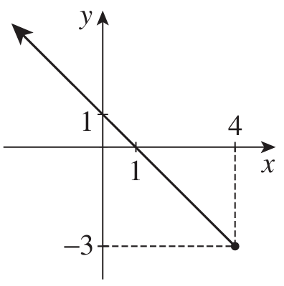
  - Find the Cartesian equation of $x=4-t^{2}, y=t^{2}-3$.
Explain why $x≤4$ and $y≥-3$ and sketch the curve.

From $x=4-t^{2}, t²=4-x$
Substituting into $y = t² - 3$:
$$y=(4-x)-3$$
$$y=1-x$$
$$∴x+y=1$$
Domain and range restrictions:
Since t² ≥ 0:
$$x=4- t; x=4-t²≤4$$
$$y=t^{2}- 3; y=t²- 3≥- 3$$
The Cartesian equation is x + y = 1 with x ≤ 4 and y ≥ – 3.

- Consider $\left(t^{2},t^{2}-1\right)$. Jimmy claims that the graph is just the graph of $y=x-1$,
whereas Jenny claims that it is only the right-hand side of the graph.
Determine who is correct, you can start by substituting some values of $t$ and plotting the graph.

Mary is correct as she considers that $t^{2}≥0$, so the domain is $x=t^{2}≥0$.
- Write in Cartesian form.
- $x=1+2\tan{θ}$  $$y=3\sec{θ}-4$$  $$tan θ =\frac{x - 1}{2}$$  $$\sec{θ}=\frac{y + 4}{3}$$  Using sec²θ - tan²θ = 1:  $${\left(\frac{y + 4}{3}\right)}^{2} - {\left(\frac{x - 1}{2}\right)}^{2}= 1$$  $$4{\left(y+4\right)}^{2}-9{\left(x-1\right)}^{2}=36$$ | - $x=\cos{θ}+\sin{θ}$  $$y=\cos{θ}-\sin{θ}$$  $$x+y=2cosθ→cosθ=\frac{x+y}{2}$$  $$x-y=2sinθ→sinθ=\frac{x-y}{2}$$  Using cos²θ + sin²θ = 1:  $${\left(\frac{x + y}{2}\right)}^{2} + {\left(\frac{x - y}{2}\right)}^{2} = 1$$  $$(x + y)² + (x - y)² = 4$$  $$2x² + 2y² = 4$$  $$∴ x² + y² = 2$$  $$x^{2}+y^{2}=2$$

- 2021 VCE Specialist Mathematics
A function is defined parametrically by
$$x\left(t\right)=5\cos\left(2t\right)+1, y\left(t\right)=5\sin\left(2t\right)-1$$
If $A\left(6,-1\right)$ and $B\left(1,4\right)$ are two points that lie on the function, then find the shortest distance along the graph from $A$ to $B$.

$$\cos{2t}=\frac{x-1}{t},\sin{2t}=\frac{y+1}{5}$$
$$\cos^{2}\left(2t\right)+\sin^{2}\left(2t\right)=1$$
$${\left(x-1\right)}^{2}+{\left(y+1\right)}^{2}=25$$
$A$ and $B$ are the rightmost and topmost points on the circle, so the shortest arc connecting them is a quarter of a circle.
$$d=\frac{2πr}{4}=\frac{5π}{2} units$$

- HSC Sample Question Band 5
A curve has equation $\frac{{\left(y-2\right)}^{2}}{9}$ $-$ $\frac{{\left(x+1\right)}^{2}}{4}$ $=1$
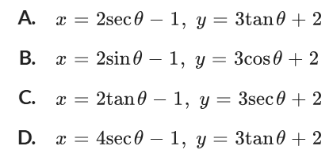
Which of these is the curve in parametric form?
Try each option by substituting $x$ and $y$, simplifying LHS and seeing which gives you 1.
Consider option C:
$$LHS=\frac{{\left(3\sec{θ}+2-2\right)}^{2}}{9}-\frac{{\left(2\tan{θ}-1+1\right)}^{2}}{4}$$
$$=\frac{9\sec^{2}{θ}}{9}-\frac{4\tan^{2}{θ}}{4}$$
$$=\sec^{2}θ{-\tan^{2}{θ}}$$
$$=1$$
So C is the answer.

